Project template

By

Sam Cai

Contents

Analysis 3

Problem Identification 3

Describe and justify the features that make the problem solvable by computational methods. 3

Explain why the problem is amenable to a computational approach. 3

Stakeholders 3

Identify and describe those who will have an interest in the solution explaining how the solution is appropriate to their needs 3

Research the problem 3

Research the problem and solutions to similar problems to identify and justify suitable approaches to a solution. 3

Describe the essential features of a computational solution explaining these choices. 3

Explain the limitations of the proposed solution 3

Specify the proposed solution 3

Specify and justify the solution requirements including hardware and software configuration 3

Identify and justify measurable success criteria for the proposed solution. 3

Design 10

Implementation 11

Testing 12

Evaluation 13

# Analysis

Project Outline

## Problem Identification

### Describe and justify the features that make the problem solvable by computational methods.

1. Game mechanics: Developing a game with complex mechanics that allow for player interaction, character development, and game progression requires computational approaches. This involves creating algorithms and data structures to handle game mechanics such as character attributes, game physics, and AI-controlled non-player characters.
2. Graphics and Animation: Developing high-quality graphics and animation requires extensive computational resources and expertise. Computational methods such as 3D modeling, animation software, and graphic rendering engines allow for the creation of immersive and visually stunning game worlds.
3. Player Input: Games rely heavily on player input and interaction, which can be handled efficiently through computational methods. This includes user interfaces, input devices, and input processing algorithms that allow for real-time and responsive gameplay.
4. Testing and Optimization: Computational methods also enable the testing and optimization of game mechanics, graphics, and performance. This includes simulating gameplay scenarios, testing performance on various hardware configurations, and optimizing game elements for better performance and user experience.

### Explain why the problem is amenable to a computational approach.

1. An adventure fantasy forest-themed game involves a complex set of rules, mechanics, and interactions between the player, environment, and characters. A computational approach allows for the efficient and effective management of these interactions through algorithms, data structures, and programming techniques. It also enables the creation of realistic and immersive game worlds that respond to player input, making it an ideal approach for developing such a game.

## Stakeholders

### Identify and describe those who will have an interest in the solution explaining how the solution is appropriate to their needs

1. The stakeholders in a game include players, game developers, publishers, and investors. Players are the primary stakeholders, and they have an interest in the game's mechanics, graphics, storyline, and overall experience. Game developers are responsible for creating the game, ensuring its functionality, and designing its features. Publishers are responsible for marketing and distributing the game, while investors are interested in the game's profitability and financial returns.

## Research the problem

1. To develop an game, it is essential to research similar games and identify their strengths and weaknesses. This research will help in understanding the genre's mechanics, themes, and design elements that make it successful. Additionally, researching player preferences, feedback, and reviews will help identify areas of improvement and features to incorporate into the game.

### Research the problem and solutions to similar problems to identify and justify suitable approaches to a solution.

### Describe the essential features of a computational solution explaining these choices.

1. should include several essential features. These features include:

* A rich and immersive game world with detailed graphics and interactive elements.
* A variety of characters, enemies, and creatures with unique abilities and personalities.
* An engaging storyline with quests, challenges, and puzzles to solve.
* A player progression system with rewards, upgrades, and achievements.
* Intuitive controls and a user-friendly interface.
* Multiplayer capabilities to allow players to collaborate or compete with others.

### Explain the limitations of the proposed solution

* Technical limitations: Developing a game with detailed graphics, complex mechanics, and interactive elements can be challenging, requiring extensive technical expertise and resources.
* Time constraints: Developing a high-quality game can take several months, and delays in the development process can impact the game's success.
* Compatibility: Ensuring that the game is compatible with various platforms, devices, and operating systems can be challenging, requiring extensive testing and optimization.
* Player preferences: The success of a game is ultimately dependent on player preferences, and designing a game that appeals to a broad audience can be challenging.

## Specify the proposed solution

1. The proposed solution is to develop a game that immerses players in a detailed and interactive game world. The game will feature a variety of characters, enemies, and creatures with unique abilities and personalities. Players will embark on quests and solve puzzles to progress through the game, earning rewards and upgrading their abilities as they go. The game will have intuitive controls and a user-friendly interface, allowing players to focus on the gameplay experience.

### Specify and justify the solution requirements including hardware and software configuration

* Hardware: A computer with a modern processor, graphics card, and sufficient RAM to support the game's graphics and processing requirements.
* Software: The game will be developed using a game library, pygame, which provides tools and libraries for game development.

### Identify and justify measurable success criteria for the proposed solution.

The success of the proposed solution can be measured through various criteria, including:

* Player engagement: Measured through metrics such as active players, and playtime, indicating the level of player interest and satisfaction with the game.
* Bug-free gameplay: Measured through metrics such as the number of reported bugs and crashes, indicating the stability and quality of the game.

# Design

# Implementation

Tech

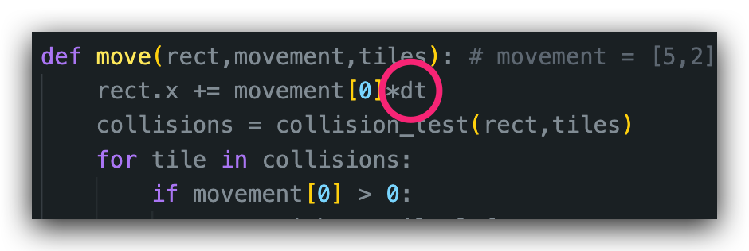

Framerate Independence – The game runs at the same speed regardless of the framerate, so we can change the rendered FPS and not affecting the speed of the game.

In this case, we have the variable FPS = 120 and DESIRED_FPS = 60, meaning that the game will render internally at the pace of 60 times per second, while rendering displaying 120 images to the screen every second.

Notice that in the game loop, the game is updated every 1/120 of a second but the movement or the overall effect is scaled down by the dt, because if we call the refresh_dt() function more frequently, the value of dt gets smaller.

# Testing

# Evaluation

# Documentation: